The registry is responsible for the administration of the Commission.

Operations
During the 2024-25 financial year data has been collected across the three main service delivery areas of the Commission’s operations: intake and assessment, facilitation of conferences and hearings, and supporting CE activities outside of conference.
The Commission received and assessed 6,831 notices of which 4,595 were within the Commission’s jurisdiction. The majority of within jurisdiction notices received this financial year were for school attendance, followed by Magistrates Court, domestic violence orders, child safety and welfare, and then Childrens Court notices. Information regarding our performance during the year is located in the Non-financial performance outcomes and the Review of financial performance sections.

At a glance – the 2024-25 year
6,831  Agency notices assessed | 4,595  Agency notices deemed within jurisdiction | 1,145  Community members deemed the subject of agency notices
793  Conferences and hearings held | 442  Community members prioritised for conferences and hearings | 479  Not served conference slots
1,796  CE activities held outside of conference | 721  Community members supported in the 1,796 CE activities | 543  Non-contact CE activities
509  Hours spent supporting CE activities | 0  Appeals of FRC decisions

A capable administrative workforce is key to an efficient, agile and innovative organisation.
The FRC’s administrative workforce in the Commission’s registry consists of:
- the Commissioner (appointed by the Governor in Council for a specified term) who as the Chief Executive Officer (CEO) is responsible for ensuring the efficient discharge of the Commission’s business, appropriate training for registry staff and Local Commissioners, the preparation of corporate documents and achieving the objects of the FRC Act as specified in section 22 of the FRC Act.
- the Deputy Commissioner. Under section 44 of the FRC Act the Commissioner may delegate the Commissioner’s functions to a Deputy Commissioner and under section 25 of the FRC Act the Deputy Commissioner may act as the Commissioner in certain circumstances.
- the Registrar who is responsible for managing the registry and the administrative affairs of the Commission and whose functions, powers and delegation are specified in sections 35 to 37 of the FRC Act
- the Executive Officer (Corporate) who is responsible for providing financial and strategic/corporate advice and support to the Commission’s operations across Cairns and the communities
- an Executive Assistant to support the Office of Commissioners plus 15 additional positions across the four teams of Compliance and Legal Policy, Corporate, Case Management and Monitoring, and Coordination. The Coordination team includes five Local Registry Coordinators appointed under section 38 of the FRC Act to support the efficient and effective operation of the Commission in each of the welfare reform communities.

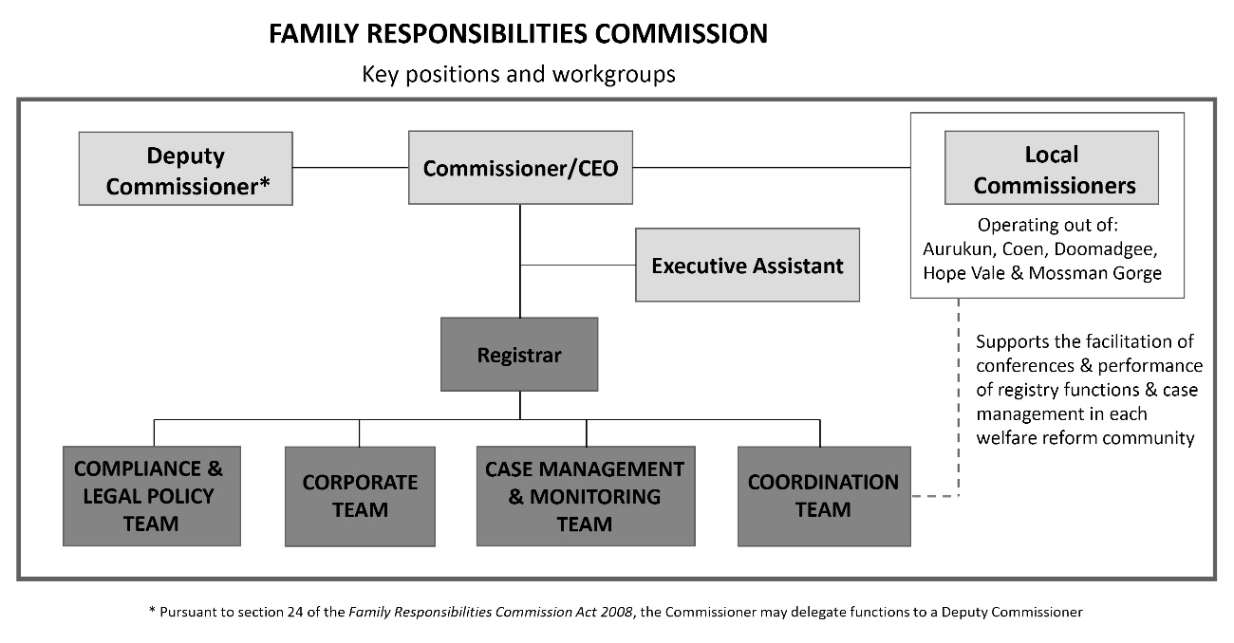
Further details relating to the Commission’s workforce profile can be located in the Governance section of this report. Biographies of Commissioners and the Registrar can be found in the appendices (Appendix C).

A client-centred approach to registry systems and processes
Business and operational strategies this year have continued a focus on maximising results for clients by internally strengthening the FRC model to achieve accountability and continued relevance in a changing policy environment.

Coordination team – Over the past year, the Coordination team has grown to include the Manager (Coordination) and five Local Registry Coordinators, each supporting one of the five welfare reform communities. The Local Registry Coordinators play a vital role in facilitating efficient operations across their communities, including the coordination of conferences, maintaining records and strengthening connections between clients and community support services.

Activity data for 2024-25 financial year: Snapshot of the Coordination team’s workload
793  Conferences and hearings held across five communities – averaging approximately 23 conferences and hearings per week over a 34-week schedule | 805  Occasions where notices were served on persons to attend conferences and hearings (including clients, support persons and other relevant persons) | 479  Not served conference slots
1,796  CE activities held outside of conference | 721  Community members supported in the 1,796 CE activities | 543  Non-contact CE activities
509  Hours spent supporting CE activities | 6.0  Full time employees of the Coordination team

A major focus for 2024-25 has been CE outside the formal conference setting. This proactive approach has helped maintain strong levels of positive engagement, with voluntary referrals to support services and voluntary income management reflecting steady community participation. These voluntary engagements reflect clients’ growing sense of personal responsibility and self-determination.
There has also been strengthened collaboration through the ESR initiative, promoting school attendance and addressing education-related matters through early engagement. This shift towards supporting clients through CE, aligns with our broader strategic goals to:
- increase voluntary participation and shared decision-making
- invest in education as a foundation for community development and Closing the Gap outcomes
- respond flexibly to changing community needs in line with the FRC Act.
In preparation for the reinstatement of the Childrens Court trigger, the Coordination team and Local Commissioners undertook targeted training. With the passing of legislative amendments to the FRC Act, the Commission can again receive Childrens Court advice notices for young offenders. This important change strengthens our ability to provide early, coordinated interventions and referral pathways for families of repeat youth offenders, with the goal of addressing underlying issues and preventing reoffending.

Case Management and Monitoring (CM&M) team – Responsibilities for the CM&M team include the following:
- receiving and processing agency notices
- determining jurisdiction
- gathering information for consideration of agency notices
- setting conference and CE timetables
- processing conference and CE outcomes
- managing CIM and VIM processes
- monitoring CCPs from FRAs and orders and VCPs
- ensuring compliance with the FRC Act.
The team also provide support to Local Registry Coordinators in their further engagement with community members outside of the conference setting through initiatives such as ESR and Intensive Case Management.

Activity data for 2024-25 financial year: Snapshot of the CM&M team’s workload
6,831  Agency notices assessed to determine jurisdiction – averaging approximately 131 notices assessed per week | 267  Community members on non-voluntary active case plans had their progress monitored throughout the year (for periods between 3 to 12 months) following conference. | 3.0  Full time employees of the CM&M team

The Coordination and CM&M teams together have established a cohesive group to provide high-level support and information to Local Commissioners to better inform the delivery of support to clients in line with the Commission’s focus on more intensive, quality, client-centred conferencing.

Compliance and Legal Policy (C&LP) team – The C&LP team are responsible for the delivery of compliance, legal and policy advice across the Commission’s operations. The C&LP team also plays a large role in strengthening and managing aspects of the Commission’s corporate governance, including quality assurance of decision-making.
In addition to the ongoing provision of internal and external advice the C&LP team have undertaken several major projects in the reporting year, including:
- beginning a holistic review of the Commission’s suite of policies
- preparing submissions and giving evidence to parliamentary inquiries on matters relevant to the FRC and its clients
- providing advice to government on proposed legislative changes, including the reinstatement of the Children’s Court ‘trigger’.

Corporate team – The Corporate team are responsible for the delivery of accounting, payroll and accounts payable functions, Information and Communications Technology (ICT), statistics and research, travel, infrastructure and other corporate related activities.
In addition, the Corporate team have undertaken several major projects in the reporting year, including:
- commencing the upgrade of its Customer Relationship Management (CRM) system and ICT infrastructure (refer page 77 for more details).
- assessing the FRC’s accounting functional requirements and exploring alternative software solutions, resulting in the identification of a successful supplier and the approval to proceed. The new accounting software system is expected to be implemented during the 2025-26 financial year (refer pages 77 and 78 for more details).
- the office relocation project which was a key focus during the 2024-25 financial year, involving extensive planning, coordination and preparation to ensure a smooth transition to the new premises.

Commissioners are responsible for decision-making at conferences and hearings.
Commissioner Williams, Deputy Commissioner Curtin and 36 Local Commissioners appointed across the five welfare reform community areas of Aurukun, Coen, Doomadgee, Hope Vale and Mossman Gorge, preside over locally convened conferences and hearings involving community members and make legally binding decisions.

Constitution of conferences and hearings
The FRC’s continuation of assurance and oversight mechanisms throughout the 2024-25 financial year resulted in quality decision-making with improved client-focused outcomes and contributed to the result of no appeals against Commission decisions by community members.

Commission decisions use local authority and are made within a legal framework.
The FRC Act requires the decision-making panel to include locally appointed Commissioners. During the reporting period 787 conferences were held and constituted by using the following combinations:
- three Local Commissioners sitting without the assistance/advice of the Commissioner or Deputy Commissioner (section 50A conferences, monitored under section 50B) with one of the Local Commissioners acting as the chairperson
- three Local Commissioners sitting as a panel (section 50A conferences, monitored under section 50B) with one of the Local Commissioners acting as the chairperson and with assistance/advice provided by the Commissioner or Deputy Commissioner
- two Local Commissioners sitting with the Commissioner or Deputy Commissioner acting as chairperson.

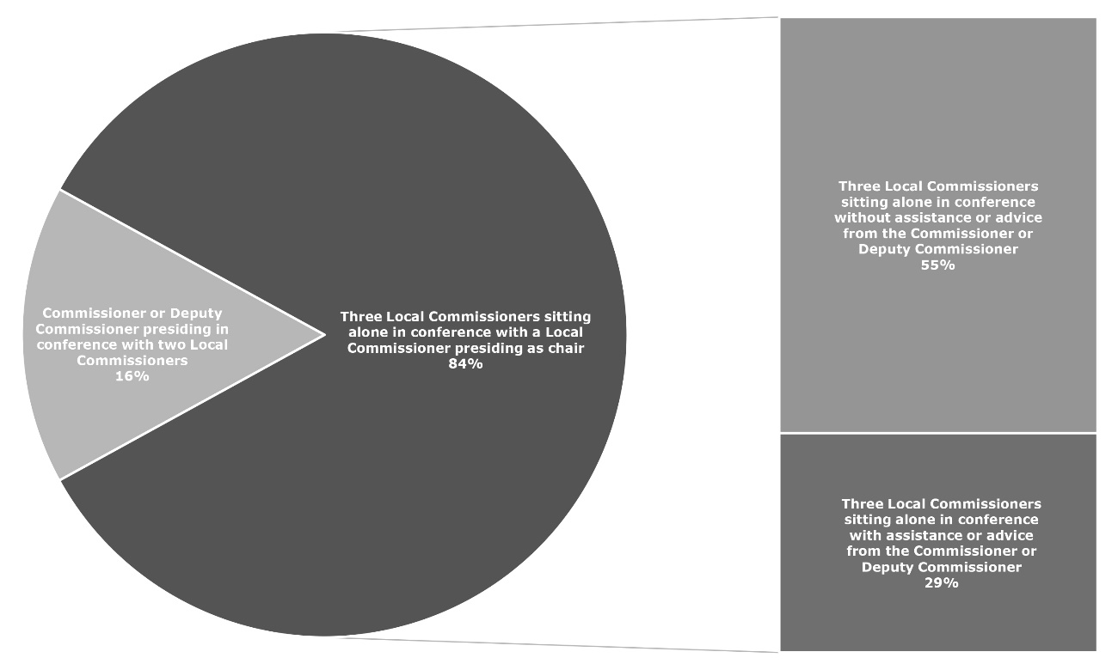
When deciding to hold a conference in relation to a community member named in an agency notice it is the function of the Commissioner to appoint up to three Local Commissioners to comprise the panel and decide the matter, having regard to the knowledge and experience of each Local Commissioner to determine the issues to which the agency notice relates, cultural and gender diversity considerations and potential conflicts of interests.

Conference Constituted 2024-25
Graph 4: Constitution of conferences 1 July 2024 to 30 June 2025
As seen in previous years the vast majority (84%) of Commission decisions at conference throughout 2024-25 continued to be made by three Local Commissioners sitting alone to constitute the panel.

Quality assurance and oversight of decisions
All Commission decisions are made within a legal framework. There are mechanisms in place to ensure appropriateness and consistency of FRC decisions including:
- the appointment of a legally trained and suitably qualified Commissioner, and Deputy Commissioner if appointed, with the statutory function to ensure the efficient discharge of Commission business including the holding of conferences and making decisions about agency notices under the FRC Act
- monitoring of Commission decisions when made at conference by a panel comprised of three Local Commissioners sitting alone
- the delivery of regular and appropriate training to Local Commissioners and registry staff to perform their statutory duties and achieve the objects of the FRC Act
- the creation of the Compliance and Legal Policy team within the registry to provide advice to the Commissioner and members of the Commission’s Executive Management Team (EMT), and drive quality assurance practices.

The Commissioner is required under the FRC Act to monitor all decisions made at conference by a panel constituted entirely by three Local Commissioners, to ensure consistency of decision-making. Commissioner Williams, with the assistance of Deputy Commissioner Curtin, does so in several ways.
Firstly, Local Commissioners can seek legal advice and guidance from the Commissioner or Deputy Commissioner prior to determining a matter at conference. Throughout the 2024-25 financial year 659 conferences were presided over and constituted by three Local Commissioners sitting alone, and for 229 of these conferences Local Commissioners sought legal advice and guidance from either the Commissioner or Deputy Commissioner (these are deemed ‘Commissioner assisted conferences’ for reporting purposes).
Secondly, following all conferences the Commissioner conducts a review of every outcome. In this reporting period 58% of decisions were monitored by Commissioner Williams within 28 days of the date of conference.
The FRC remains committed to building the capability of Local Commissioners, so they continue to make reasonable and proportionate decisions reflective of the evolving and often complex needs of community members, their families and broader community expectations and standards of behaviour. The FRC provides regular training and assistance to Local Commissioners to support their ongoing ability to perform their duties as statutory decision-makers.
During the reporting period Commissioner Williams and Deputy Commissioner Curtin delivered training content to Local Commissioners in small groups within their respective communities, on topics relevant to their individual capabilities and requirements. With the reintroduction of the Childrens Court notice, training was delivered to the Local Commissioners by the Deputy Commissioner and the Manager, Compliance and Legal Policy, between September 2024 and June 2025. The training covered the amendment to the FRC Act that operationalised the Childrens Court trigger notice, and the impact and process changes for the Local Commissioners in the course of client conferencing and CE activities.

Commissioner assisted conferences | 2022-23 | 2023-24 | 2024-25
Percentage of three Local Commissioners sitting without the assistance/advice of the Commissioner or Deputy Commissioner | 45% | 72% | 55%

Application hearings held to consider changing needs of community members
Each application to amend or end an agreement (including a voluntary agreement) or order follows a transparent process and is considered by the Commissioners on its own merit whilst observing the principles of natural justice. A timely decision on the application is made under the FRC Act pursuant to section 99 for a FRA or order, or section 109 for a voluntary agreement, and may include either agreeing or refusing to amend or end an agreement or order. Alternatively, if the Commissioners deem the application for an FRA or order frivolous or vexatious they may decide to dismiss the application.
For an application received under section 97 of the FRC Act, if the Commission fails to make a decision within two months of receipt of the application, section 101 of the FRC Act determines that the failure is taken to be a decision by the Commission to refuse to amend or end the FRA or order. For an application to amend or end a voluntary agreement, section 109(2) of the FRC Act states: “The Commissioner must amend or end a voluntary agreement as requested by the person, unless the Commissioner is satisfied the amendment or ending would be detrimental to the interests, rights and wellbeing of children and other vulnerable persons living in a welfare reform community area”.

Decisions on amend/end applications for FRAs or orders
Following the decision of the Commission at conference relating to an agency notice, a community member who is the subject of that decision can make an application to the FRC seeking to alter or end the original decision because their circumstances or behaviours have changed. During this reporting period 7 amend/end applications were decided for orders.

Decisions on amend/end applications for voluntary agreements
A person who has entered into a voluntary agreement about VIM with the Commissioner can ask the Commissioner at any time to amend or end the agreement. During this reporting period 17 amend/end applications were decided for VIM agreements.

Timeframe on deciding applications in 2024-25
Number of applications decided in  2024-25 | Average number of days to make a decision in 2024-25
7 applications to amend or end a CIM | 17.00 days
17 applications to amend or end a VIM | 8.23 days

The opportunity afforded in hearing these applications is utilised by the Commissioners to encourage clients to continue to address any remaining challenges and to exercise personal responsibility in their lives.

Timely decision-making with increased client participation
The Commission continued its focus throughout the 2024-25 reporting period on timely decision-making and on encouraging agreements to be made in the first instance (pursuant to sections 46 and 68 of the FRC Act). The efforts of Local Commissioners to encourage clients to have agency in the FRC’s decision-making process cannot be over-estimated. Increased client participation facilitates better outcomes through personal commitment and a shared consideration of a balance of options available to clients.

Conference attendance | 2022-23 | 2023-24 | 2024-25
Conference attendance | 67.0% | 65.7% | 66.5%

Additionally in 2024-25, the majority of conferenced agency notices were determined within two conferences (with the client), whilst 88% of clients who were served a notice to attend a conference participated in the FRC’s decision-making process by attending at least once.

FRC decisions have a focus on capacity-building and self-determination.
Decisions can be made by agreement or order of the Commission. Community members can also voluntarily request referrals or income management. A continuum of possible decisions made at conference follows.

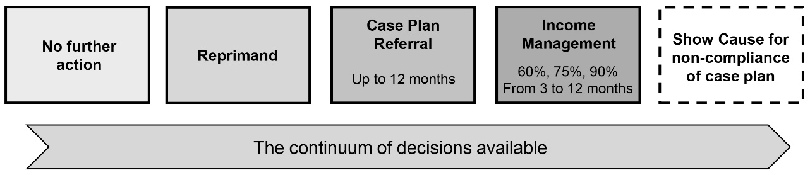

Section 5 of the FRC Act is clear in stipulating that matters should be dealt with in a manner that facilitates early intervention, delivers timely decisions, supports the change of behaviour sought, supports the exercise of local authority and makes use of community support services.

Engagement at conference
As can be seen from the table below, clients continue to assume personal responsibility demonstrating insight regarding their actions at the earliest opportunity (i.e., agreements entered into at conference). As a proportion of all decisions in 2024-25 to attend support services in conference, 65% were by agreement.

Conference outcomes | 2023-24 | 2024-25 | % change
Agreements to attend community support services | 284 | 190 | -33%
Orders made to attend community support services | 100 | 102 | +2%

Further information regarding conference activity and outcomes during the reporting period can be found in the Non-financial performance outcomes section.

Voluntary engagement – a ‘right fit’ for many who self-refer
The FRC Act sets out a process for voluntary engagement in which a community member can self-refer to the Commission and voluntarily seek help for a referral to a community support service under a VCP or to be subject to VIM.
The FRC is continuing to see a number of clients who engage with the FRC on a voluntary basis highlighting that community members are exhibiting a heightened self-awareness of their personal circumstances and are willing to accept assistance from the Commission at the earliest opportunity.

Voluntary income management
VIM agreements are seen as a useful tool to assist community members to manage their budgets and meet the cost of everyday essentials. A number of elderly community members (who have not otherwise been referred to the FRC) are volunteering to have a portion of their welfare payments subjected to income management to help safeguard funds for their own needs and protect from humbugging and/or other elder abuse or violence. The Australian Institute of Health and Welfare defines an “Older Indigenous Australian” as aged 50 and over. Out of the 89 clients who entered into a VIM during 2024-25, 38% (34) of these clients were aged 50 and over.

Number of voluntary agreements for VIM | 2022-23 | 2023-24 | 2024-25 | % change 2023-24 to 2024-25
Voluntary agreements for VIM | 118 | 115 | 97 | -16%

Number of clients with voluntary agreements for VIM | 2022-23 | 2023-24 | 2024-25 | % change 2023-24 to 2024-25
Clients with voluntary agreements for VIM | 100 | 104 | 89 | -14%%

As at 30 June 2025 there were 67 clients on a VIM who were claiming Centrelink payments for 51 children of which 32 were of school age.

Voluntary income management and conditional case plans
During conference Local Commissioners focus on reaching an agreement with clients in the first instance whilst explaining the benefits of service referrals, even if only to develop a budget and savings plan to aid in the management of money on the SmartCard.
The Commission is seeing a number of clients who attend conference and, although they may receive a compulsory referral under a CCP from an FRA or order (subject to show cause if required), they may also volunteer to be on a period of income management.

Clients on CCPs, VCPs and VIMs | 2022-23 | 2023-24 | 2024-25
Number of clients on a VIM with a CCP only | 42 | 22 | 13
Number of clients on a VIM, CCP and VCP only | 9 | 15 | 12

The Commission is seeing an increase in the number of clients who self-refer without a mandated requirement to attend conference. As can be seen in the next table these clients engage with the FRC on an entirely voluntary basis. The FRC considers these clients to be the best indicator of a community member’s willingness to take greater personal responsibility with increased expectations of themselves and their families.

Clients on VCPs and/or VIMs | 2022-23 | 2023-24 | 2024-25
Number of clients on a VIM only | 26 | 27 | 26
Number of clients on a VIM with a VCP only | 21 | 32 | 37
Number of clients on a VCP only | 11 | 78 | 85

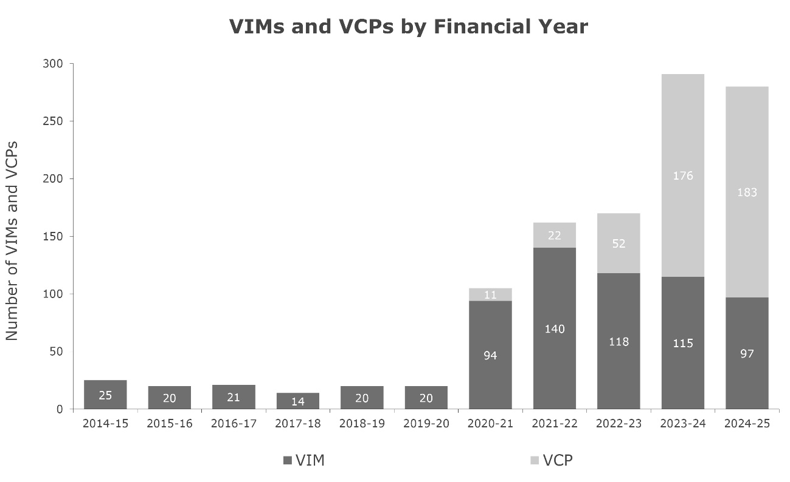
As is evident from the following graph, the Commission is seeing a continued overall increase in the number of voluntary case plans entered into with clients over the last four financial years.
Graph 5: Number of VIMs and VCPs by financial year 1 July 2014 to 30 June 2025

Number of VCPs and VIMs | 2020-21 | 2021-22 | 2022-23 | 2023-24 | 2024-25
Total number of voluntary agreements | 105 | 162 | 170 | 291 | 280

Conditional case plans and conditional income management
Conditional income management alone does not reduce welfare dependency and cannot be expected to rectify the multiple and complex issues of poverty, disempowerment, addiction, child abuse and neglect, violence and offending. The graduated range of FRC decisions provides a system of local authority through which FRC clients can be appropriately encouraged to take up responsibility and access the supports needed to build the capabilities required to break the cycle of disadvantage.
A total of 267 clients were placed on a CCP in 2024-25 either through a FRA or an order to attend community support services. Out of the 267 clients, 90% of these clients (241) were placed on a CCP without a CIM, reflecting the intent of the Local Commissioners decision-making powers to provide avenues for their community members to receive appropriate support to address their behavioural issues.

Clients placed on a CCP without a CIM | 2021-22 | 2022-23 | 2023-24 | 2024-25
Percentage of clients placed on a CCP without a CIM | 82% | 92% | 92% | 90%

Referral pathways and case management

Conditional referrals
Commissioners are guided by the FRC Act, sections 4 and 5, to encourage community members to engage in socially responsible standards of behaviour and in doing so, to make appropriate use of community support services. The Commissioners use the referral pathways available in each community to help strengthen clients’ resilience to face the challenges they experience, and to ensure the wellbeing and safety of children and vulnerable people.
During the conferencing process Commissioners may decide to refer the client to support services such as:
- Wellbeing Centres (WBCs) to address alcohol and/or drug misuse, gambling, DV or social and emotional health-related issues
- parenting programs to assist in implementing good parenting practices
- MPower, a money management program, to assist with budgeting and meeting priority financial needs
- School Attendance Officers to assist parents to ensure children attend a school
- other appropriate support services.

As demonstrated in the table below the Commissioners have continued to make a number of referrals from FRAs and orders.

Number of referrals from FRAs and orders | 2022-23 | 2023-24 | 2024-25
Conditional referrals to service providers | 499 | 472 | 342

During 2024-25, 267 clients were referred to attend support services under either an FRA or order. The percentage of finalised conferenced clients who were referred decreased from 67% in 2023-24 to 65% in 2024-25.

Percentage of finalised conferenced clients referred | 2022-23 | 2023-24 | 2024-25
Percentage of finalised conferenced clients referred | 62% | 67% | 65%

Where a client has multiple or complex issues to address Commissioners may refer the client to more than one support service. Referrals to support services may be made on the basis of an FRA, where a client agrees to attend a support service, and the client and Commissioners agree on the action to be taken together. Alternatively, Commissioners may make a decision to direct a client to attend a support service/s. Progress reports are received from service providers and clients are assessed to determine if they are fulfilling their obligations under the agreement or order. Together with local knowledge additional information may be sought from agencies and service providers, where appropriate, under Part 8 of the FRC Act to provide the best support possible for the client. Service providers and other persons who can make a useful contribution to the conferencing process are encouraged to attend conference proceedings and discuss the decision-making processes with the Commissioners.

Voluntary referrals
Under section 106(a) of the FRC Act a community member may ask the Local Registry Coordinator for a welfare reform community area to refer the person to a community support service.
The FRC has seen an increase of 4% in the number of VCPs entered into from 2023-24. This is indicative of the broader acceptance by community members to undertake personal responsibility.

Number of voluntary agreements for VCP | 2022-23 | 2023-24 | 2024-25 | % change 2023-24 to 2024-25
Voluntary agreements for VCP | 52 | 176 | 183 | +4%

Number of clients with voluntary agreements for VCP | 2022-23 | 2023-24 | 2024-25 | % change 2023-24 to 2024-25
Clients with voluntary agreements for VCP | 44 | 152 | 158 | +4%

Number of referrals from VCPs | 2022-23 | 2023-24 | 2024-25 | % change 2023-24 to 2024-25
Voluntary referrals to service providers | 55 | 190 | 186 | -2%

Conditional income management – a nuanced approach of ‘last resort’
At conference a decision may be made to issue a client with a CIM order. Due consideration is given to the individual circumstances of the client and whether alternative action is more appropriate. CIM orders are considered as a last resort, with Commissioners endeavouring to enter into an FRA with the client agreeing to CIM in the first instance.
Following conference, the Commission is required by the FRC Act to notify the Secretary of the Department of Social Services (DSS) with details of the CIM, whereby the community member’s welfare payments are income managed by DSS in accordance with the decision of the Commission and remain subject to FRC’s continued jurisdiction. The SmartCard is issued to the community member by Services Australia (SA) to reflect the Commission’s CIM under an order or agreement.
The Commissioners use CIM as a tool to support people and children at risk, promote socially responsible choices, and as an incentive to meet individual and community obligations by drawing together a network of support services to focus on the individual’s needs. CIMs are issued for a defined period (no longer than 12 months) with the Commissioners determining whether 60, 75 or 90 percent of fortnightly welfare payments are managed. Community members may apply to the Commission to have their CIM amended or ended. Commissioners consider each application to ascertain whether the client has made sufficient progress to justify an amend or end decision. Details of the process available to FRC clients, seeking to end or change their income management status are discussed in the relevant section on pages 34 and 35.

Number of CIMs | 2022-23 | 2023-24 | 2024-25 | % change 2023-24 to 2024-25
Number of CIMs | 64 | 54 | 36 | -33%

Percentage of finalised conferenced clients CIM’d | 2022-23 | 2023-24 | 2024-25
Percentage of finalised conferenced clients CIM’d | 11% | 11% | 8%

Applications to amend or end agreements or orders
Applications to amend or end an agreement (including a voluntary agreement) or order are considered an important means of ensuring that FRC decisions remain applicable to the changing needs and circumstances of clients. This mechanism affords clients an opportunity to apply to the Commission to amend or end their agreement or order by providing their reasons for making the application. Commissioners view the hearing of the applications as an opportunity to engage with clients.

Applications to amend or end received | 2022-23 | 2023-24 | 2024-25
Applications to amend or end received | 35 | 26 | 29

Statistical reporting and analysis of referenced data
Additional statistical reporting and analysis of the data referenced in this chapter can be found at the Commission’s Non-financial performance outcomes section of this report.

Number of not served conference slots due to medical, no longer living in community, not suitable time, out of the community, in prison, sorry business or substance affected.
Number of non-contact CE activities with 50 instances related to administrative support, such as preparation for upcoming CEs and 493 instances involved unsuccessful attempts to engage with a client for to the following reasons: medical, no longer living in community, not suitable time, out of the community, in prison, sorry business, substance affected/aggressive and unable to locate.
This figure records the total time attributable to all CE activities inclusive of contact and non-contact activities. In December 2024 the time spent field of the CE spreadsheet was updated from 15 minute graduations to 5 minute graduations to provide more practical options reflective of the time spent for each CE activity.
Number of not served conference slots due to medical, no longer living in community, not suitable time, out of the community, in prison, sorry business or substance affected.
Number of non-contact CE activities with 50 instances related to administrative support, such as preparation for upcoming CEs and 493 instances involved unsuccessful attempts to engage with a client for to the following reasons: medical, no longer living in community, not suitable time, out of the community, in prison, sorry business, substance affected/aggressive and unable to locate.
This figure records the total time attributable to all CE activities inclusive of contact and non-contact activities. In December 2024 the time spent field of the CE spreadsheet was updated from 15 minute graduations to 5 minute graduations to provide more practical options reflective of the time spent for each client engagement activity.
A pool of Local Commissioners for each welfare reform community area are appointed by Governor in Council for a term: section 12(2) and (3) of the FRC Act.
Counts in this table only include clients who had a combination of a VIM and CCP only and VIM, VCP and a CCP only, in other words there has been no CIM issued.
Counts in this table only include clients who had a VIM or VCP and no CIM or CCP.
Note the 241 clients on a CCP without a CIM does include 12 clients who were on a CCP, VCP and VIM and 13 clients who were on a CCP and VIM.
A case plan can have multiple referrals e.g. a client may be referred to both the Wellbeing Centre and MPower under the same case plan.

